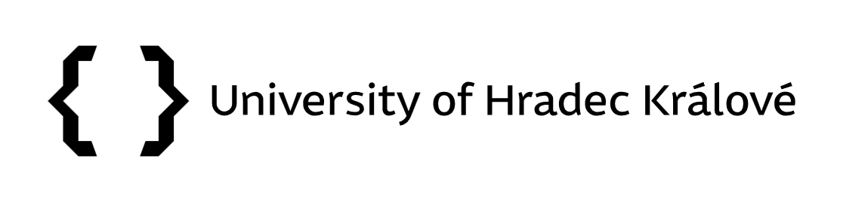
Appendix 1
Vice-Rector's Directive No. 07/2025
Application for the Open Science Award Competition
First name and surname
Workplace
Contact e-mail
Name of activity
Link to specific result
Description of how Open Science principles were applied (e.g. open access to publications, open data, FAIR data, shared code, preprint, pre-registration, open peer review, citizen involvement in research, etc.).

Brief summary of the contribution (innovation, impact, added value, usability).

In Hradec Králové on XX. XX. 2025.
Signature of the competition participant

