Article
System approach to the optimizing of tourism effects in the protected areas
Martina Pásková, David Zejda and Josef Zelenka*
Faculty of Informatics and Management, University of Hradec Králové, Hradec Králové, Czech Republic; martina.paskova@uhk.cz (M.P.), david.zejda@uhk.cz (D.Z.), josef.zelenka@uhk.cz (J.Z)
* Correspondence: josef.zelenkal@uhk.cz
Received: date; Accepted: date; Published: date
Abstract: The sustainabilization of tourism development in the protected area relies largely on the ability of its destination management to harmonize activities of visitors, local communities, entrepreneurs and other tourism actors with the aims of nature and landscape protection. To achieve this, the carrying capacity based limits of the tourism development in the given destination, has to be identified and observed. This paper strives to refine the theory of carrying capacity concept and operationalize it by applying a system approach to the destination management of the protected area. It is supplemented by a concept of dynamic and locally dependent carrying capacity, effective carrying capacity, and the concept of visitor optimum. As a result, a destination model is derived within the concept of effective carrying capacity. Verification of the model in various types of protected areas is proposed in the concluding part of the manuscript.
Keywords: carrying capacity; tourism; protected areas; visitor management; visitor optimum; destination system; destination model

1. Introduction
The protected area as a specific tourism destination represents a sophisticated system (Figure 1) with many inputs, outputs, actors, and factors. These factors reflect the weather, season, accumulated impacts, various types of pollution (e.g. industrial, agricultural, light, noise, visual one), tourismification level (Pásková, 2014), life cycle stage (Butler, 1980; Pásková, 2014), spatial and temporal patterns of visitor behavior, and functional links between destination actors, including feedback effects. The carrying capacity of a given destination depends on the structure of its system (Figure 1), its parameters (destination type, size, life cycle stage etc. and above-mentioned factors including the accumulation of influences over time). Therefore, it should be approached in a systemic way as suggested by Zelenka and Kacetl (2014).
Figure 1 Systemic specification of carrying capacity in destination. Source: Zelenka & Kacetl (2014), modified and amended
An information system reflecting the state and functioning of the area as a tourism destination and at the same time as a set of interconnected ecosystems as well as the appropriate interpretation of the data could help to determine objectively limits and intensity levels of tourism. Objectivity of the determined limits of the destination development facilitates transparency and comprehensiveness for other tourism actors, as well as enforcement of observation of these limits.
However, development of such information systems is hampered by the complexity of each destination system (number of parameters and factors) and its dynamic nature (parameters highly volatile in time and even the way the parameters interact may change in time). The relevant data may be lacking or may not be available in sufficient quality (Goossen, 2014). These are gaps in the relevant theoretical background, including the inconsistent representation of knowledge from tourism domains (Gretzel, 2011). Promising new technologies, such as deep learning, could be evaluated to deal with the issues characterized by the system complexity and insufficient data. Nonetheless, as a first step towards the systematic, responsible, evidence-based visitor management of protected areas able to harmonize the needs of tourism actors with the destination limits, the carrying capacity theoretical background has to be extended towards its operationalization. This is the main goal of the manuscript.

2. Literature Review
Increasing tourism intensity in many areas and ever-changing visitor demands and behavior patterns (e.g. Kuba et al., 2018; Leung et al., 2018) cause that planning and spatio-temporal zoning (Zelenka & Kacetl, 2013; Gundersen et al., 2019) has to continually follow the determined limits of tourism development to enforce them. To achieve this effectively, all the key tourism actors have to be involved in the destination participatory management (e.g. Pásková, 2014; Leung et al., 2018; Pásková & Zelenka, 2018). Modulation of visitor behavior, based on a thorough knowledge of the territory and visitor needs, represents currently a crucial opportunity for further development of visitor management (Bednar-Friedl et al., 2012; Leung et al., 2018).

Evolution of the Visitor Management in Protected Areas
The first generation of visitor management of protected areas in late 19th century was “anthropocentric”, i.e. primarily aimed at meeting visitor needs by promoting tourism, building infrastructure, etc. (Weaver & Lawton, 2017). This, driven by the changes in society (population explosion, well-being growth, transport advances, increase of the popularity of recreational activities in the nature, etc.), often resulted in excessive intensity of tourism with adverse and often irreversible impacts on local ecosystems and communities (e.g. Parsons et al., 1986; Bella, 1987; Ripple & Larsen, 2000).
It triggered a shift to the opposite extreme, i.e. to the “biocentric” approach focusing on elimination of pressure of humans on local nature, often implemented and enforced by strict regulation measures (e.g. Dearden & Berg, 1993; Eagles, 1993, pp. 57-70; McNamee, 1993, pp. 18-30; Hammitt & Cole, 1998). For long-term sustainability, it is undoubtedly necessary to ensure that the tourism intensity does not exceed destination carrying capacity (e.g. Wall, 1982; Canestrelli & Costa, 1991; Pásková, 2012, 2014; Zelenka & Kacetl, 2014; Marsiglio, 2017). On the other hand, sustainable tourism can play an important role in both endogeneity and diversity of local economies (e.g. Pásková, 2012, 2014; Amir et al., 2015), especially in communities living in vicinity of protected areas, and can also serve as a source of funding for nature conservation (e.g. Iranah et al., 2018; Schuhmann et al., 2019). Therefore, both extreme policies, the first generation leading to excessive visitor traffic and the second generation which does not acknowledge visitors' interests and the positive effects of tourism on the local community are untenable (Weaver & Lawton, 2017; Johnston & Tyrrell, 2005).
The mission of the third generation visitor management of protected areas is to remove specific friction areas between tourism development and nature conservation with the aim to achieve harmonious coexistence between visitors and nature (Weaver & Lawton, 2017). The nature conservation beneficial at the same time for visitors and local residents is also likely to be more accepted or even supported by them. The presence of excessive numbers of visitors can have negative impact not only on the ecosystems, but also on the integrity and authenticity of the site as well as its genius loci (Bušek, Pásková, & Zelenka, 2016). All this may cause a negative change in visitors' perception of the site and decrease their experience quality. In this way, psychological dimension of carrying capacity can be exceeded (Mason, 2015; Prokopis et al., 2019). Concepts of ecotourism (e.g. Weaver, Lawton, 2007), sustainable tourism (e.g. Clarke, 1997; Pásková, 2012, 2014), responsible tourism (Goodwin, 2002; Pásková & Zelenka, 2016; 2018), volunteer tourism (Wearing, 2001; Pásková & Zelenka, 2018) or geotourism (Hose, 2000; Dowling & Newsome, 2006; Pásková, 2018; Pásková & Zelenka, 2018) respond to the need to reconcile the above-mentioned conflicting requirements. Beyond the economic benefits, rediscovered respect for nature can influence the well-being, decision-making and behavior patterns of visitors themselves (Taylor, 1981; Ryan et. al, 2010), as well as natural identity of local inhabitants (Pásková, 2018). By systematic education and responsibisation of both visitors and local residents aiming at changing their approach from the consumer to participatory one can even make tourism a tool for protection of local ecosystems and landscape instead of a threat to them (e.g. Weaver & Lawton, 2017).

Destination as a System
Each destination represents a complex of mutually interconnected ecosystems, social and economic systems, which can absorb certain level of certain type of tourism development without irreversible deterioration of its own potential for further tourism development (e.g. Butler, 1980; Weaver, 1990, 2000; Wall, 1982; Pásková, 2012, 2014). According to Pásková (1999), the destination system can be described through its identified elements and links between them. On the bases of the „Papiercomputer“ (Pásková, 1999), she explains activity/ passivity or positivity/ negativity of the effects generated or absorbed by each of these elements. After identification of key elements of the destination system (attractivities, infrastructure, actors, environmental and social elements, etc.), their horizontal (geographical) position has to be localized and their vertical position (role, importance in the destination system) has to be recognized.
The temporal and spatial patterns of natural and related social processes in the territory and the impact of tourism must first be understood including various internal (e.g. human and financial resources of the destination management) and external factors (e.g. the legislative and economic situation in the given country, manifestations of the climate change, industrial pollution, urbanization, the penetration of invasive species, and the loss of biodiversity in adjacent territories; Zelenka & Kacetl, 2014) as well as the role, needs and behavior patterns of the different tourism actors (Albrecht, 2016). The number of visitors, their behavior patterns and impact on local ecosystems (and communities) are also influenced by other tourism actors. Appropriate social responsibility of tourism actors (e.g. visitors, destination agencies, local tourism service providers, local authorities) is another prerequisite for optimizing the tourism effects in protected areas (Pásková & Zelenka, 2016, 2018). Visitors, local residents, as well as other actors form heteregeneous groups.

Evidence-based Responsible Visitor Management
Responsible visitor management in a protected area strives for evidence-based approach to determine the optimal intensity and form of tourism, i.e. the optimal numbers and segments of visitors, their space-time distribution and the optimal focus of their activities reflecting the fragile features of local ecosystems, local community and economy. To achieve this, visitors numbers, segments and effects have to be continuously monitored, mutually correlated and accessed by an interdisciplinary team. The long-term collection, analyses and interpretation of these data enables to identify potential, optimum and limits as well as application of sustainability management (Pásková & Zelenka, 2018). The absorption capacity of the destination can be practically identified by means of the Limits of Acceptable Changes (LAC) method (Ahn, Lee, & Shafer, 2002; Frauman & Banks, 2011), tourism sustainability indicators (Inskeep & World Tourism Organization, 1998; Pásková, 2012) and visitor management models (Zelenka & Kacetl, 2013; Kuba et al., 2018; Leung et al., 2018). These approaches are conceptually linked to the idea of carrying capacity (Wall, 1982; Canestrelli & Costa, 1991; Papageorgiou & Brotherton, 1999; Salerno et al., 2013; Zelenka & Kacetl, 2014; Marsiglio, 2017), which multidimensional (Papageorgiou & Brotherton, 1999; Pásková, 2012, 2014; Salerno et al., 2013) and dynamic nature has been described in the context of its future possible operationalization (Zelenka & Kacetl, 2014).
Systems perspective and an interdisciplinary approach are prerequisites of sustainable tourism management (Liu, 2003; Pásková, 2012; Pásková & Zelenka, 2016). Modelling a destination as a system represents a promising tool for management of tourism sustainability (Cole, 2005; Skov-Petersen, 2005; Jochem, Pouwels & Visschedijk, 2006; Gimblett & Skov-Peterson, 2008). Destination model may determine the optimal numbers of visitors with respect to the specific characteristics of a particular territory (Lanchava et al., 2018), capture the intrinsic space-time behavior of its visitors (Gimblett et al., 2001), indicate tourism impacts in terms of sharing of benefits and costs among tourism-dependent and independent residents of a destination who encounter a mix of different visitor segments (Canestrelli & Costa, 1991; Pásková, 2012), applying the social exchange theory (Doxey, 1975; Pásková, 2012, 2014), price flexibility of demand (e.g. effects of admission fee changes in time and space; Steiner, 1997), or other concepts from the neoclassical economy. Optimal ecotourism intensity from an environmental and economic point of view may be inferred by modelling interactions between animal and plant species, their habitats natural processes and visitors (Bednar-Friedl et al., 2012). Potentially conflicting objectives, such as maximizing benefits provided by tourism to the economy and society of the local community and protecting the natural environment, can be examined by the means of modelling (Johnston & Tyrrell, 2005).

4. Materials and Methods
The basic aim of the research was to develop a systemic approach, based on relevant data, knowledge and technical resources, which could lead to better reconciliation of tourism development and nature conservation in highly visited yet ecologically sensitive areas, in particular the protected areas. This aim was framed by the following research questions:
1) How to define the visitation optimum of a protected area?
2) How to make best use of available relevant data for enhancement of efficiency of visitor management of a protected area?
The refinement of the formulated research questions as well as the process of searching for answers was covered by the previous work of the authors (Pásková 1999, 2002, 2012, 2014; Zelenka & Kacetl, 2013, 2014). This background as a first step of the research enabled deeper understanding of the effects produced and absorbed by various elements of destination system as well as refinement of the carrying capacity theoretical concept, and values determination and simulation processes. The method of system analysis (Firsov, 2016) was applied to describe the protected area as a destination system where the identification of the visitation optimum represent problem to be solved. The elements of destination system and their mutual relations were characterized and processes of both determining and simulating potential, optimal and threshold values of visitation as a primary independent variable were delineated. In this way, the new theoretical concept of functional model of destination was introduced, visitor optimum conceptualized and parameterized, potential and effective carrying capacity defined and mathematically described.
On this basis and by application of mathematical modelling (Firsov, 2016), (1) the methodology of destination system (hereinafter referred to as "DS") analysis and (2) the method of constructing destination model (hereinafter referred to as "DeM"), whose core is the functional model of the destination introduced above, are developed. As a result, a model application of the proposed DeM and refined carrying capacity concept are presented.
The creation of DeM was preceded by a DS analysis, aimed to identify the key elements of the DS, their variables, the possible values of these variables, the relationships between them and the factors that affect the behavior of the system. The input for this analysis consisted of the available geographic data, additional information on the territory and its key sites, the monitored natural features and their state, visitor segmentation structure and characteristics, and conservation approach to the visitor flows intensity and time-space distribution. Because of DS analyses, tourism actors’ roles, goals, activities, competences and mutual relations were recognized and described.
This analytic step was followed by the synthetic one, which consisted in the construction of the pilot version of DeM. It included, except further formalization of the findings derived by means of DS analysis, the implementation as well as final selection and definition of system elements.

5. Results

The Concept of a Functional Model of a Destination
Zelenka and Kacetl (2014) assume that an impact caused by a change of the primary independent variable value (e.g. the number of visitors) on the dependent variable value (e.g. the state of ecosystems in the protected area or the quality of life of local residents) takes place through synergy of individual impacts, both undesirable (e.g. change in traffic density or intensity congestion level at top attractions, local prices of services and goods, soil sealing level, amount of waste, built up area) and desirable (e.g. change in tourism revenues, and investments in nature conservation). However, values of dependent variables are not determined by independent variables completely, but are also affected by other internal and external factors. When constructing a model for a particular territory, from the set of all interrelations among variables the ones that manifest themselves most strongly, i.e. with highest frequency and intensity on the dependent variable, has to be identified by an expert estimate or preferably by a sensitivity analysis whenever necessary data are available. Less-influential variables and relationships may be neglected; certain variables may have to be omitted if no relevant data are available. Knowingly neglected variables and relationships should be considered when interpreting model results.
Mathematically, according to Zelenka & Kacetl (2014), the component of carrying capacity ${CC}_{k}^{\hat{G}}$ for the type of phenomenon $P_{k}$ (e.g. ecological), and for a selected geographical space $\hat{G}$ in relation to the time $t$ is defined as a function of the all significant impacts $\sum{{\text{IM}}_{i,j}^{I}}\left(t\right)$ (e.g. changes in ecosystems state) caused by significant primary influences $\sum{{\text{IN}}_{j}^{I}}\left(t\right)$ (number of visitors) and all significant time dependent both internal and external conditions $\sum{{\text{C}}_{ext}^{I}}\left(t\right),\sum{{\text{C}}_{\text{int}}^{I}}\left(t\right)$ (factors):
${CC}_{k}^{\hat{G}}\left(t\right)=fct\left(\hat{G},\sum{{\text{IM}}_{i,j}^{I}}\left(t\right),\sum{{\text{IN}}_{j}^{I}}\left(t\right),\sum{{\text{C}}_{ext}^{I}}\left(t\right),\sum{{\text{C}}_{\text{int}}^{I}}\left(t\right),P_{k},t\right)$ (1)
The carrying capacity function described by Zelenka and Kacetl (2014) served as conceptual basis for description of a more specific functional model of a destination, as a step towards the operationalization (Figure 2).
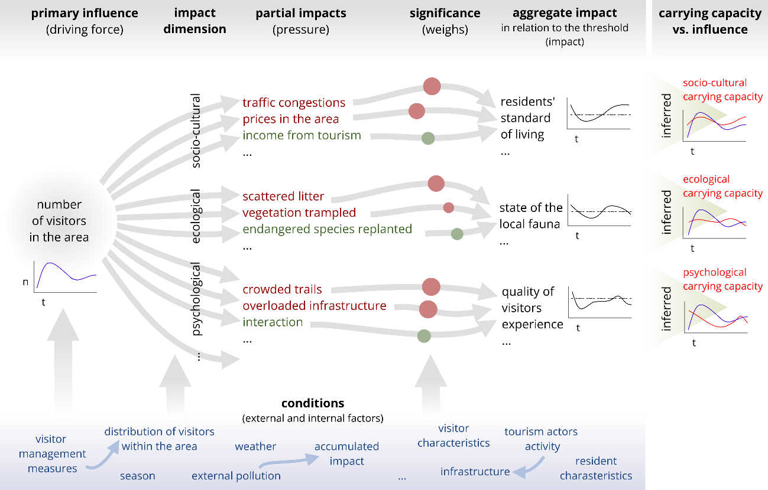
Figure 2 Functional model of a destination and a principle of derivation of the carrying capacity
The model captures the variety of partial impacts of a certain monitored independent variable (e.g. the number of visitors over time) on dependent variables in different dimensions (e.g. socio-cultural, ecological, psychological, etc.) as well as the synergic aggregation of these partial impacts within the defined dimensions (e.g. the combination of noise and light pollution; Pásková, 2012). In this way, the model represents individual relational phenomena, such as socio-cultural influence of tourism.

Parametrized Impacts
To reflect the varying significance of partial impacts, weighs are assigned to each of the partial impacts either by the consensus of experts or statistically if relevant data are available; weighs may stay constant or may vary over time or depending on other variables (technically becoming functions within the DeM). Factors (conditions) can step in and influence (1) the independent variable, (2) the partial impacts of the independent variable value, or (3) the synergic aggregation of partial impacts. Some factors manifest themselves only in one of these phases, others in several. At each stage, they may reinforce or suppress the affinity of the impact, thus act in either a desirable or an undesirable way.
For example, in a destination model, which expresses the impact of tourism intensity on vegetation in an area, weather serves as an external factor. Rainy weather deters visitors from coming (independent variable is influenced, with desirable effect in relation to the ecological dimension). Further, these visitors are likely to spend less time in the exposed locations (the desired impact in the second phase). However, presence and movement of each individual visitor will cause more serious impact in rainy weather as vegetation, soil and trails are more vulnerable in these conditions (which is an undesirable effect of the factor in the third phase).

Parametrized (conditional) Carrying Capacity
The carrying capacity is involved in the model as the highest acceptable aggregate pressure caused by the independent variable on involved dependent variables. Exceeding of this threshold would lead to irreversible adverse or for other reason unacceptable changes in the ecological, sociocultural and other dimensions of the destination. The development of the dependent variable over time can be evaluated in relation to its defined limit – minimal or maximal still acceptable value, depending on the character of the dependent variable (e.g. the highest still acceptable negative change in the quality of life of the local population; the lowest still acceptable income from tourism to sustain the local economy). If the level of the dependent variable moves beyond/below the limit, it indicates that the corresponding dimension of carrying capacity is exceeded. The difference between the limit value of the dependent variable and the actual (measured, calculated) value of the dependent variable indicates to what extent the carrying capacity (in its specific dimension) is either exceeded or not reached. In addition, as the value of carrying capacity in the model may change in time, depending on internal and external factors, it can be called parameterized carrying capacity. Conditional carrying capacity is parametrized carrying capacity under fixed parameters.

Mathematical Description
Mathematically, the functional model and derivation of carrying capacity can generally be described as follows:
Partial impact ${PIM}_{i}$ of the primary influence ${\text{IN}}_{j}$at a time $t$ in the area $\hat{G}$ influenced by a set of internal and external factors ${\text{C}}_{\text{int}}^{\hat{G}}\left(t\right)∪{\text{C}}_{\text{ext}}^{\hat{G}}\left(t\right)$ is defined as a function ${pim}_{i}^{\hat{G}}$:
${PIM}_{i,j}^{\hat{G}}\left(t\right)={pim}_{i}^{\hat{G}}\left({\text{IN}}_{j}^{\hat{G}}\left(t\right),{\text{C}}_{\text{int}}^{\hat{G}}\left(t\right)∪{\text{C}}_{\text{ext}}^{\hat{G}}\left(t\right),t\right)$ (2)
Aggregate impact ${\text{AIM}}_{j}$ of the primary influence ${\text{IN}}_{j}$ at a time $t$ in the area $\hat{G}$ on the variable $J$ is defined as a sum of all partial impacts ${PIM}_{i,j}$weighed by respective functions $w_{i}$, taking into account a set of internal and external factors ${\text{C}}_{\text{int}}^{\hat{G}}\left(t\right)∪{\text{C}}_{\text{ext}}^{\hat{G}}\left(t\right)$:
${\text{AIM}}_{j}^{\hat{G}}\left(t\right)=\sum{w_{i}^{\hat{G}}}\left({PIM}_{i,j}^{\hat{G}}\left(t\right),{\text{C}}_{\text{int}}^{\hat{G}}\left(t\right)∪{\text{C}}_{\text{ext}}^{\hat{G}}\left(t\right),t\right)$ (3)
Considering
- 1:1 relation between the aggregate impact and a dimension of the carrying capacity for an area (i.e. exactly one aggregate impact relates to each carrying capacity dimension)
- and $B_{j}^{\hat{G}}\left(t\right)$ as a known still acceptable limit value of the variable $J$ affected by the aggregate impact ${\text{AIM}}_{j}$,
the level of the primary influence ${\text{IN}}_{j}$ a time $t$ in the area $\hat{G}$ is acceptable if:
- $J_{0}^{\hat{G}}\left(t\right)+{\text{AIM}}_{j}^{\hat{G}}\left(t\right)<B_{j}^{\hat{G}}\left(t\right)$, where $B_{j}^{\hat{G}}\left(t\right)$ is the highest acceptable value and $J$has a immediate character, or
- $J_{0}^{\hat{G}}\left(t\right)+{\text{AIM}}_{j}^{\hat{G}}\left(t\right)>B_{j}^{\hat{G}}\left(t\right)$, where $B_{j}^{\hat{G}}\left(t\right)$ is the lowest acceptable value and $J$ has a immediate character, or
- $J^{\hat{G}}\left(t-1\right)+{\text{AIM}}_{j}^{\hat{G}}\left(t\right)<B_{j}^{\hat{G}}\left(t\right)$, where $B_{j}^{\hat{G}}\left(t\right)$ is the highest acceptable value and $J$ has a cumulative character, or
- $J^{\hat{G}}\left(t-1\right)+{\text{AIM}}_{j}^{\hat{G}}\left(t\right)>B_{j}^{\hat{G}}\left(t\right)$, where $B_{j}^{\hat{G}}\left(t\right)$ is the lowest acceptable value and $J$has a cumulative character.
This binary function (denoted as ${acc}_{j}^{\hat{G}}\left(t\right)$ for further reference) express at any given time whether the level of the primary influence ${\text{IN}}_{j}$in the area $\hat{G}$ is acceptable or not.

Model Variables Characteristics
Both evident and unknown functional relationships may exist between individual partial impacts and factors, causing synergistic strengthening of effects or their mutual elimination.
In addition, weighs may change over time, especially if the instantaneous or accumulated partial impact value is close to a specified limit. For example, traffic congestion may initially have little impact in the overall effect on the quality of life of local residents. However, as soon as it exceeds a threshold and becomes uncomfortable, its influence will start to grow as it represents an increasingly pressing issue for the locals. The occurrence of self-dependency of variables and both positive (amplifying) and negative (self-regulating) feedback can be expected.
To implement the DeM, it may be appropriate to define artificial variables expressing an interaction or a sum of two or more variables, or to introduce variables that express only approximate estimates. It is important to keep track of such steps in the DeM construction, so it can be taken into the account in the interpretation of the model results. The utilization of the irritation index (also called 'irridex') concept in order to capture the total impact of tourism perceived by the local community (Doxey, 1975; Pásková, 2012; Zelenka & Kacetl 2014; Pásková, 2014) may serve as an example of an artificial but still meaningful variable.
Also, the difference between instantaneous and cumulative quantities has to be distinguished consistently, both during the DeM construction and when interpreting the results. For example, the condition of vegetation cover at the site is a cumulative variable. The continual trampling of the flora by visitors in relation to particular conditions (accompanied by disturbances caused by other factors) affects the state of the vegetation cover, however at the same time, its natural regeneration also takes place (Johnston & Tyrrell, 2005).
This difference is also reflected by means of the character of partial impacts in the character of aggregate dependent variables and, ultimately, in the character of individual dimensions of carrying capacity. The ecological carrying capacity typically reflects in particular cumulative effects and hence the long-term aggregate impact of the determining variable (how local ecosystems change due to the effects of determining variable for a relatively long period). The psychological carrying capacity typically reflects the immediate effect (if there are too many visitors in a place, their aggregate benefit from the visit is reduced). The socio-cultural carrying capacity reflects both immediate and long-term effects. These may include immediate impact of a large number of visitors on traffic situation, the occupancy rate of parking lots, congestion of public spaces, but also the long-term effects like the transformation of residential facilities into tourism infrastructure or building new tourism infrastructure which interferes with the life of local residents, an increase in price of local products, etc. In addition, potential measures to regulate visitor traffic may also have variously delayed effects. Therefore, it can easily happen that when a particular measure comes into effect, the effect is no longer desirable. It illustrates, that for evidence-based responsible visitor management just the real-time knowledge about the destination system may not be enough. However, well-defined DeM may also serve for predictions and scenario modelling.

Spatial Aspects of a Model
The carrying capacity of the area has its spatial structure. According to Lawton (2001) up to 95% of national park visitors limit their movement to a very small part, about 5%, of the total territory its area. So, even if the visitor management follows objectives regarding the whole area, individual sites may require specific attention, such as those where tourism and nature conservation collide intensely, whether it is caused by high visitor numbers, the type of visitor activity, level of visitors social responsivity, the site´s high environmental sensitivity, or any combination of parameters. The spatial structure of the carrying capacity is illustrated in Figure 3 with both touristically overused and underused sites within a larger protected area.
DeM can be built for either a large protected area (e.g. a national park) or for an individual site. The site can be for example, a national nature reserve, a part of a trail, scenic point, a camping site, a habitat or site-specific ecosystem, or virtually any sufficiently homogeneous space within a larger heterogeneous area. However, applying the model strictly to areas homogenous with regards the relevant dimension of carrying capacity can lead to the selection of impractically or even unfeasibly small territorial units, especially for the environmental dimension. Therefore, aggregate values for larger territorial units may have to be used instead (Zelenka and Kacetl, 2014). Separate DeMs for individual sites may have to be further integrated into a compound model of the wider area, honoring the relations between the variables in the individual submodels (e.g. the measured and estimated numbers of visitors and their flows between individual sites). In the case of Železné hory (Iron Mountains) Protected Landscape Area (Figure 3), DeM for each identified key site has to be constructed together with one integratory DeM.

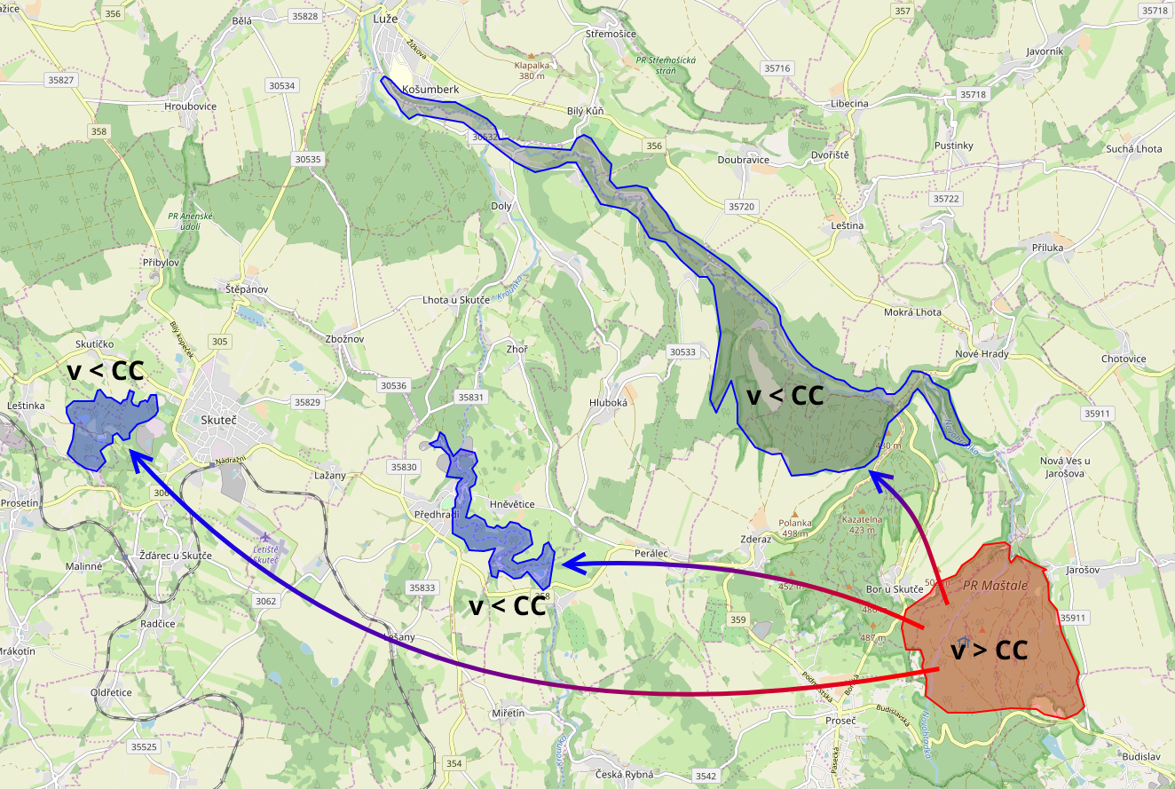
Figure 3 The Železné hory (Iron Mountains) Protected Landscape Area as an area for which a functional destination model is being constructed, with both touristically overused and underused sites. Source of map: openstreetmap.org

Visitation Optimum
Following earlier research (Pásková, 2014; Zelenka & Kacetl 2014; Weaver & Lawton, 2017) and inspired by neoclassical economic theory, the new concept of visitation optimum is introduced to identify the tourism intensity, characterized by the optimal effects in the larger time-space context. Visitation optimum for a given area at any given time can be defined as a number of visitors in the destination, which generates the optimal impact on its area. It means the minimal possible risks of exceeding of any relevant dimension and the spatial structure of the carrying capacity of the area and at the same time the highest possible utility for the key tourism actors (visitors, local community, nature conservation and local economy). Rise or drop of the visitation level from this optimum cannot lead to increase in utility (benefit, satisfaction) for any involved actor, which would neither diminish the utility of other actor nor cause exceeding the carrying capacity. The concept is based on the following assumptions:
- The use of protected area by tourism exceeding any dimension of carrying capacity at any time or any part of its territory is not acceptable. For example, exceeding ecological carrying capacity would lead to irreversible degradation of ecosystems and their services provided to all organisms living in their territory, which is in direct contradiction to the concept of sustainable development (Papageorgiou & Brotherton, 1999). Exceeding psychological carrying capacity would result in decrease of overall visitor benefit; the additional benefit to new visitors is outweighed by the loss of other visitors' benefit. Exceeding socio-cultural carrying capacity would lead to long term or even irreversible impact on local people's quality of life.
- There is a form and interval of tourism intensity in a protected area, which is not just acceptable but even desirable. Its desirable effects consist of benefits that tourism brings to the local community, visitors and other tourism actors. With appropriate education, social and environmental responsibility activation and subsequent cultivation of visitor behavior, tourism can bring also effects useful for local ecosystems. Visitors' self-identification with the nature may be strengthened by the visit, cultivating their behavior and habits and making them more responsible.
- The extent of the tourism impact is influenced by a number of internal and external factors whose values vary at different speeds over time (Zelenka & Kacetl, 2014).
- The territory consists of smaller relatively homogenous units characterized by a different development of carrying capacity dimensions over time, depending on external factors (Zelenka & Kacetl, 2014).

Effective and Potential Carrying Capacity
The introduction of the spatial structure of the carrying capacity of the area makes it possible to distinguish the effective and potential carrying capacity of the territory (Pásková, 2014). The effective carrying capacity corresponds to the structure and status of the destination at any given moment. It is determined mainly by spatial and temporal distribution of the visitor/interpretative infrastructure and services as well as other elements of the visitor management. It is also influenced by the segmentation structure of visitors, taking their social responsibility as a segmentation base. The potential carrying capacity expresses the maximum visitation intensity that a protected area could accommodate without exceeding the carrying capacity of its territorial units, assuming the best available space-time distribution of visitors.
In this context, the difference between the practical and theoretical visitation optimum has to be recognized. The practical optimum related to effective carrying capacity visitation optimum of the territory represents an optimal intensity of visitor attendance corresponding to the structure and state of the territory at a given moment. The potential carrying capacity represents a theoretical optimum determining which level of visitor intensity the area could theoretically accommodate in the case of best possible visitor management leading to best possible space-time distribution and visitor segmentation structure. Potential carrying capacity is unattainable in practice, however identifying the gap between effective carrying capacity and potential carrying capacity can help uncover the untapped potential for sustainable tourism in otherwise constant conditions, in particular the state of tourism infrastructure and typical visitor behavior pattern in the area. Therefore, the main task of the visitor management should be to reduce the identified gap to the minimum.

Sample Scenario
The proposed theory, including the concepts of visitation optimum, spatially structured and parametrized/conditional carrying capacity, is illustrated by the following sample scenarios.

The Effect of Reactive and Proactive Visitor Management
The concept of visitation optimum can be illustrated on the scenario of a hypothetical protected area (Figure 4) which is little visited at first, and its potential for tourism is not sufficiently activated, leading to an insufficient desired impact on the local economy and community well-being and a suboptimal aggregate visitor benefit. However, visitor attendance over time increases gradually and it first exceeds the ecological carrying capacity and then the psychological carrying capacity. In terms of both immediate visitor benefit and the state of local nature, it is a suboptimal and unsustainable state in the long-term. The return to a desirable level below the carrying capacity can be caused, for example, by the spontaneous decline of visitor interest in the protected area. The reason is excess of the psychological carrying capacity, which leads to negative referencing e.g. on social networks, and as a feedback, less visitors are attracted (Pásková, 2014:87-139), but also by newly implemented restrictive visitor management measures (e.g. Pásková, 2014:196-200).
However, had the visitor management measures not been implemented quickly enough, irreversible changes in the protected area may have already occurred (typically soil erosion around trails or banks of the rivers, damage to natural formations, change in species composition of flora and fauna). Proactive and preventive visitor management (Albrecht, 2016) would have been better in this case. It could have stimulated the tourist use of the area (e.g. in coordination with the destination agency or other tourism actors) in order to reach the visitor optimum and subsequently retained the desired level of tourism combining proactive and reactive measures (v2 curve). A prerequisite for proactive visitor management is a profound knowledge of the destination and its workings, of the carrying capacity levels, of the destination development of key variables over time and of tools that can effectively influence visitation flows and intensity.

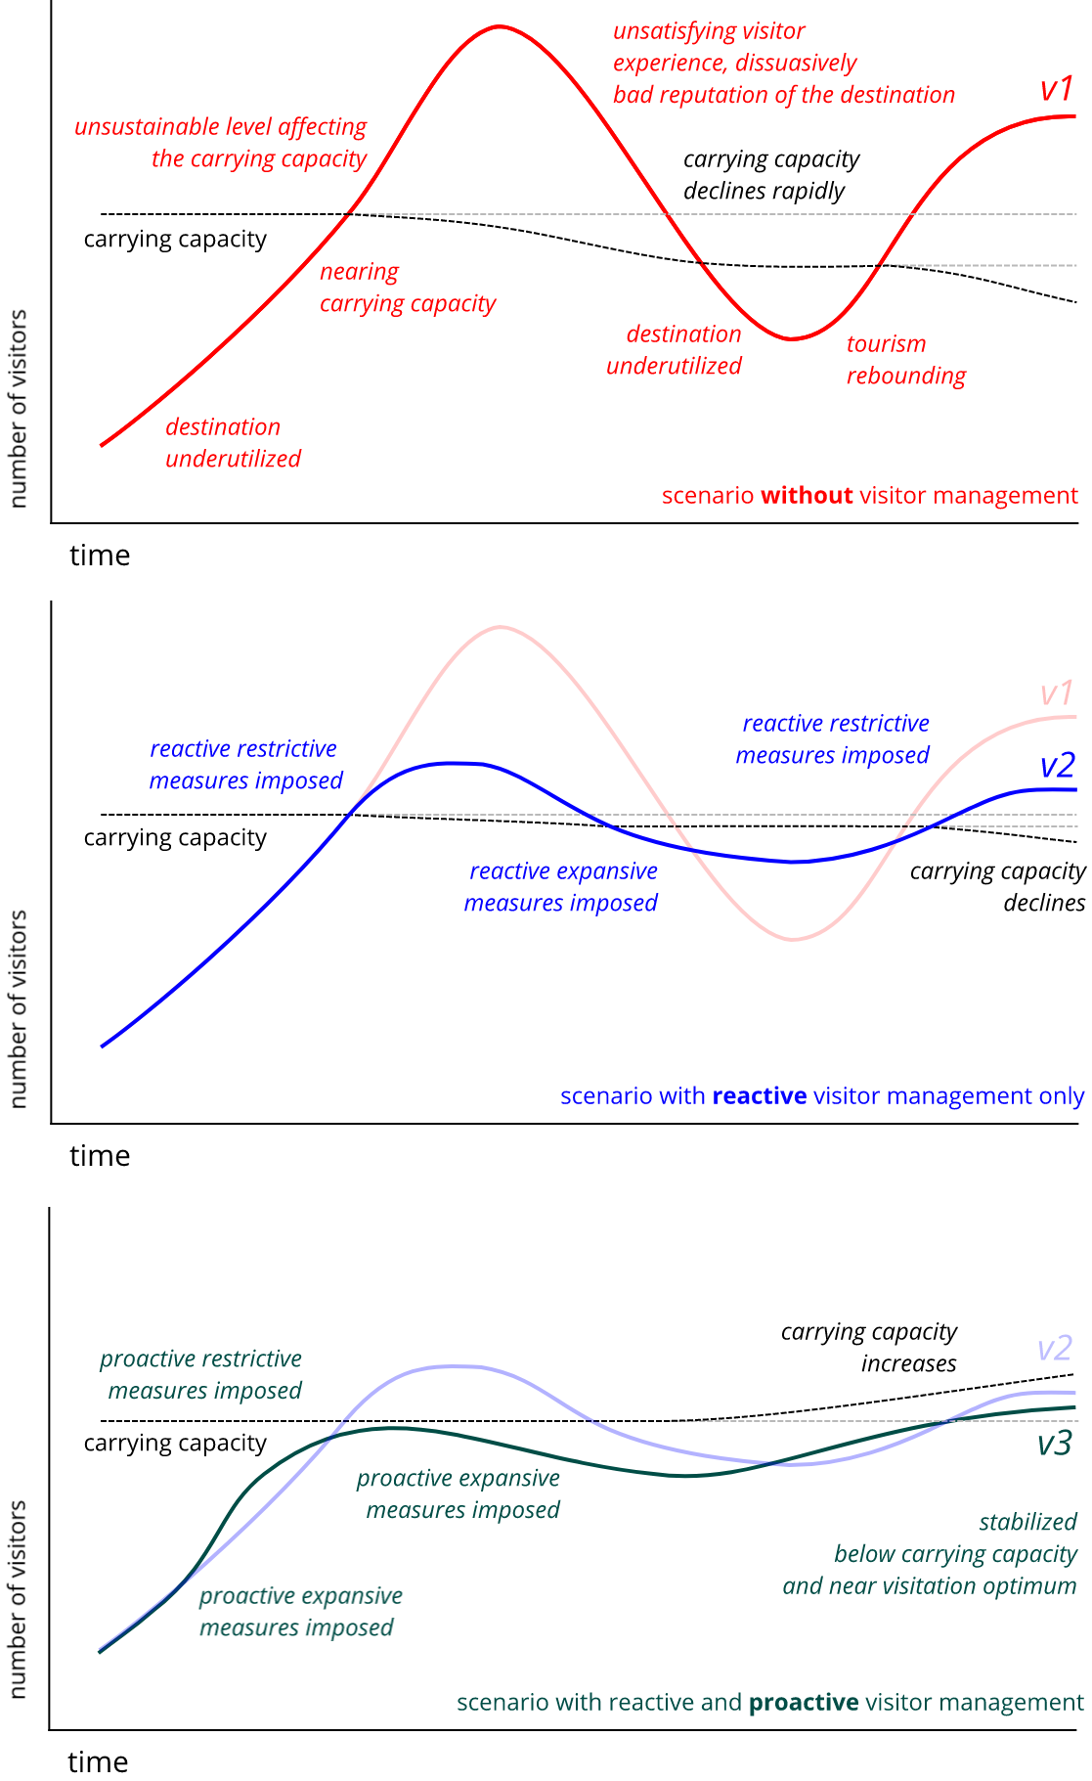
Figure 4 Visitors management scenarios (without any visitors management - v1 curve, with reactive - v2 curve, or proactive - v3 curve visitor management) showing its influence on value of carrying capacity.

The Spatial Structure of the Carrying Capacity
Subsequently, visitor flows and behavior analysis allows to determine that most visitors are heading to site, where carrying capacity is already reached, while other interesting sites might absorb higher numbers of visitors. Appropriate measures are therefore to be taken, such as adjustments in tourist trails, their signage and tourist navigation/information systems, promotion in printed materials and social media as well as pricing policy. Consequently, a bigger portion of visitors decides to visit the identified location instead of the intensively visited site (Figure 3 and 5). Due to the more appropriate distribution of visitors in space and time, the originally fully utilized location is no longer a bottleneck of the whole territory. The total carrying capacity of the area increases. Visitor attendance can then grow sustainably towards this increased carrying capacity of the territory.
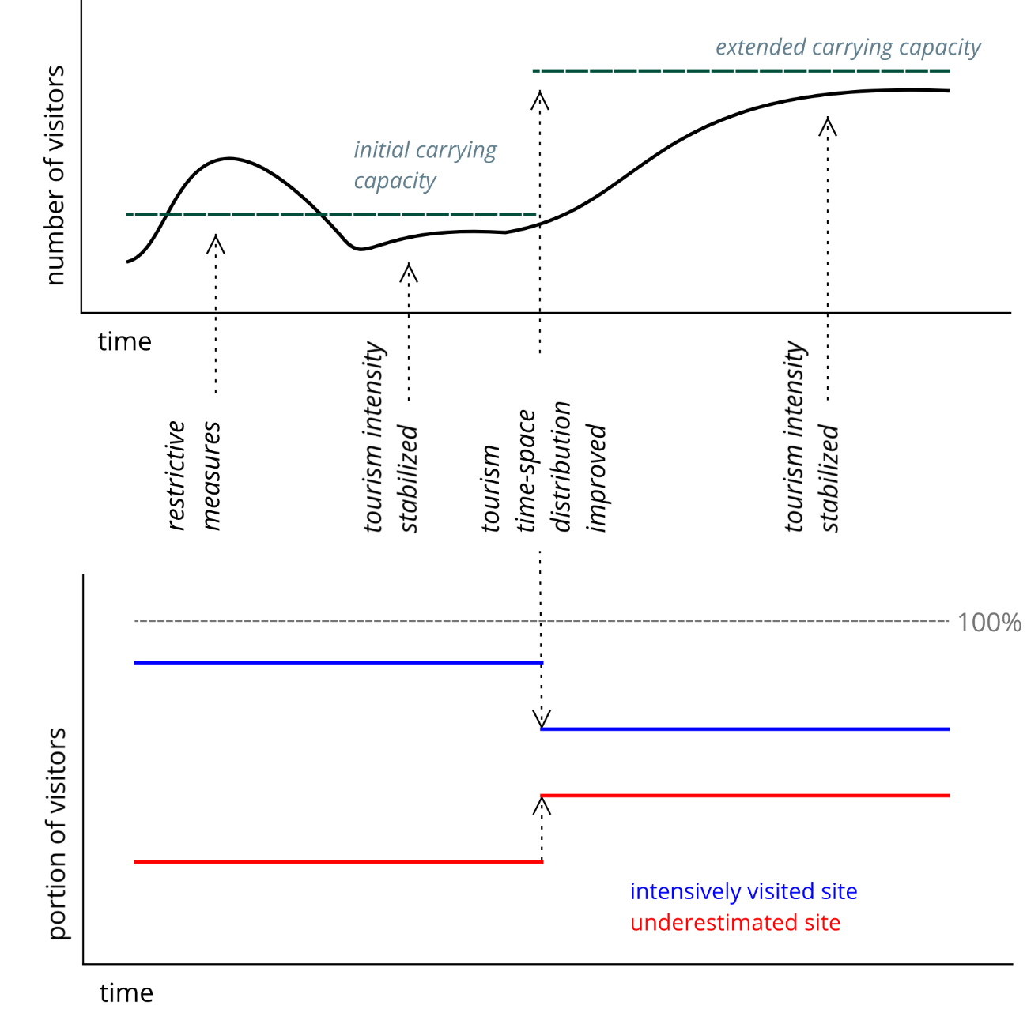Figure 5 Carrying capacity extension through improvement of visitor management.
In-depth knowledge of the spatial structure of the area visitation and specific impacts on the system allows to implement set of measures which modulate the visitor attraction and respect towards specific sites and in this way, time-space behavior of visitors is changed and their sensitivity increased, which gradually increases the effective carrying capacity and keeps the numbers of visitors below this limit (Figure 6). Although the measures have succeeded in increasing the effective carrying capacity and acceptable numbers of visitors (leading to various positive outcomes), the potential carrying capacity of the area is still far from being reached.
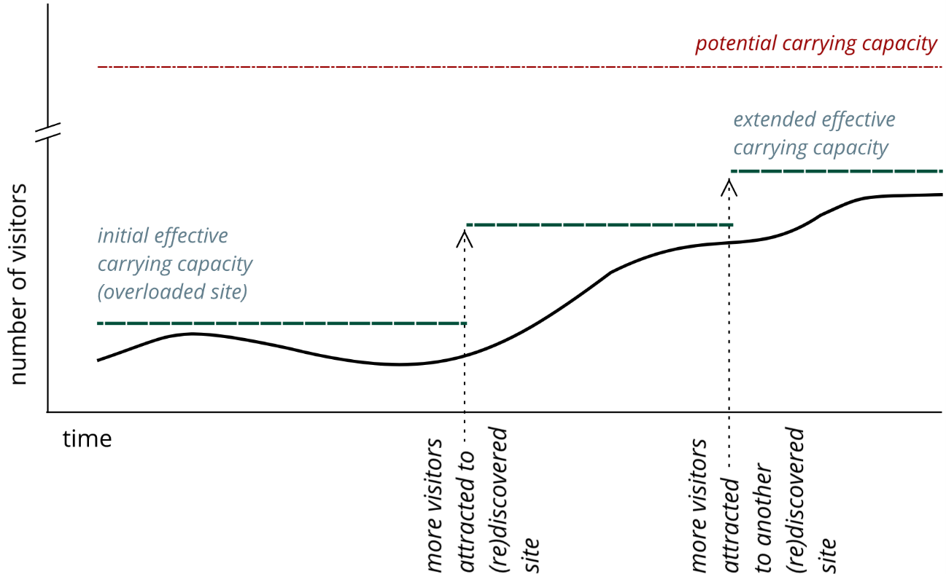
Figure 6 Potential carrying capacity of the site.

Operationalization of the Proposed Functional Model of the Destination System

System approach and information support
Visitor management in a protected area has to be based on the knowledge of the optimal intensity and form of tourism, such the visitation level, its space-time pattern and character of visitors' activities, which has an optimal effect on all the destination dimensions and actors. System approach is needed to gain initial in-depth knowledge of the current structure and the state of the system, to formulate an appropriate strategy (e.g. to keep visitor numbers of individual sites of the protected areas near their visitor optima and gradually increase effective carrying capacity towards the potential carrying capacity) and implement the strategy by appropriate measures. The behavior of the destination and each of its monitored sites is a result of the interconnected interaction of a number of actors and factors that vary at different rates over time. Impacts of independent variables are manifested in different dimensions (ecological, psychological, etc.) and individual carrying capacities of sites also have more dimensions. Visitors form a heterogeneous group with different behavior patterns and hence different impacts on nature. Having the vast complexity of the destination system on mind, it is hard to imagine sustainable, responsible, evidence-based visitor management without a support by a complex information system able to capture and reflect a selection of characteristics of the destination system.

Ongoing implementation
In participation with protected area authorities and destination managements of not just Železné hory (Iron Mountains) Protected Landscape Area, but also České Švýcarsko (Bohemian Switzerland) National Park, Broumovsko Protected Landscape Area, Český ráj (Bohemian Paradise) Protected Landscape Area, the authors are participating on an implementation of a destination application involving DeMs for each of these areas. Each DeM intends to reflect in a suitable degree of detail and accuracy each protected area as a whole, its individual parts and the patterns of its functioning. In this way, the partial DeMs of selected sites are being constructed within the areas whenever necessary.
Each model includes geospatial data, namely the key sites and hiking trails between them. The territory as a whole and the selected sites are structured in the model by a set of variables and their values, reflecting important elements in the model (e.g., in the ecological dimension, it is fauna, flora, water elements, geologic and geomorphologic elements), their state and sensitivity to independent variables (e.g., visitor numbers and their characteristics).
The functioning of each destination system is then captured in the model as the interaction of the detected input quantities (independent variables and factors defined by the functional model of the destination, e.g. weather, soil moisture, level of industrial pollution) according to defined relations, resulting in new values of the output variables (including variables affected by the defined functional model of the destination). The output variables can serve as part of the input for another iteration and in different roles either as factors, determining, or dependent variable (e.g. the current state of vegetation or the circannual cycle of animal and plant species occurring in the site which influence the impact of visitors presence but at the same time may be affected by visitors presence). Each iteration (interaction between variables and factors) brings the model into a new state. Computation in each iteration cycle reflects the flow of time, divided into discrete intervals.
Each DeM distinguishes which values of the variables are given externally, in particular in the form of a linked data source (e.g., the number of visitors detected) and which are derived by approximation, by applying functional relationships defined in the model, or by another method. Examples of derived values are the number of visitors on the day when the counting device was not working, the predicted number of visitors in the future, or the contribution of the number of visitors measured on a particular day in particular weather to vegetation cover trampling in a monitored site. The variables can be either immediate (e.g., actual number of visitors) or cumulative (number of visitors per day, number of visitors per year, erosion caused by visitors).

Iterative Model Building and Its Verification
Each DeM is being built iteratively. Elements (e.g. location, variables) and relationships (functional or stochastic dependencies) expertly identified as the most important ones are being included item-by-item. The match between calculated predictions of selected variables and the real state of the system (measured, observed) will be evaluated to assess the quality of each model in various aspects. The aim is for the model to operate robustly, i.e. under various combinations of conditions (parameters). Therefore, sensitivity analysis (dependence between the values of factors and model functioning) is also intended for testing. The iterative modifications involve introducing new elements, adjusting relationships between the existing elements as well as removing of unnecessary elements. Moreover, new data sources (e.g. inputs from sensors) will also be gradually added.
Whenever a real value of a variable which is normally computed in the model becomes available (e.g. if the state of vegetation cover in a monitored site is asessed in-situ), the actually measured value of the variable is injected into the model. Any significant dissonance between the predicted and measured value is to be analyzed to identify the possible causes (e.g. an error in functional relationships within the model, or by an error in the input data, alternatively by the presence of a significant but still unknown influence) and make appropriate adjustments. The search for the cause may result in a recommendation to modify the model, for instance by adding a newly revealed phenomenon significantly influencing the observed variable.

Individual versions of each DeM are stored together with relevant data for subsequent analyses. Keeping different versions of each DeM together with the relevant data allows comparison of the quality of different versions of DeMs. Keeping the history of versions and the relevant data may allows to maintain output consistency and explainability, which may be important if the outputs serve as a basis for a particular measure. The versioning adds an extra dimension to the data and it also increases the demand for ensuring their persistence. Currently we rely on common relational databases however, if the amount, velocity and/or variability of the data grows rapidly (quick iterations leading to high sampling frequency, many variables, many locations monitored, multiple versions of DeMs) or if the need for specialized analytical manipulation of the data grows (quick slicing along dimensions, visualision of the data, looking for patterns, etc.), it may eventually be necessary to use specialized data warehouse technology suitable for big data.

Application of Results by a Particular Visitor Management System
Based on the available data, the DeM updates the values of output variables to reflect the system in real time. The same type of iteration computation cycles but with all measured data inputs substituted with their estimates (predictions, approximations, depending on the type of the input), the same model may serve for prediction of future states of the whole destination system. It may be also used for simulation of scenarios, such as the impact of the presence of different numbers and segments of visitors (bikers, hikers, mountain climbers, boaters, etc.) on individual sites in the course of the year, effects of different spatial and time distribution of visitors or the sensitivity to external factors.
Even the process of the systems analysis of the destination system may enrich the knowledge about the territory, its visitors, their behavior and impact on local natural and cultural landscape elements, the carrying capacity and the role of other actors. Based on the knowledge, and with the help of the destination application involving the DeM, strategic goals of the visitor or traffic management may be defined more precisely and carried out both efficiently and effectively. As a result, tourism can be contained below the effective carrying capacity (near visitation optimum), none of its dimensions; the effective carrying capacity may be gradually increased towards potential carrying capacity, minimizing or eliminating the adverse effects of tourism and maximizing summary benefits for tourism actors at the same time.
Protected area management may combine complementary measures to carry out the goals both restrictive and stimulating. They may involve direct bans (forbidden entry, supplemented by relevant sanctions for violation), economic measures (admission price, parking, taxes and fees), infrastructural (capacity of nearby car parks, accommodation facilities, public transport), informational or marketing-based (promotion of selected places or even discouraging visiting some places), or targeted individual advice (provided in information centers, etc.).
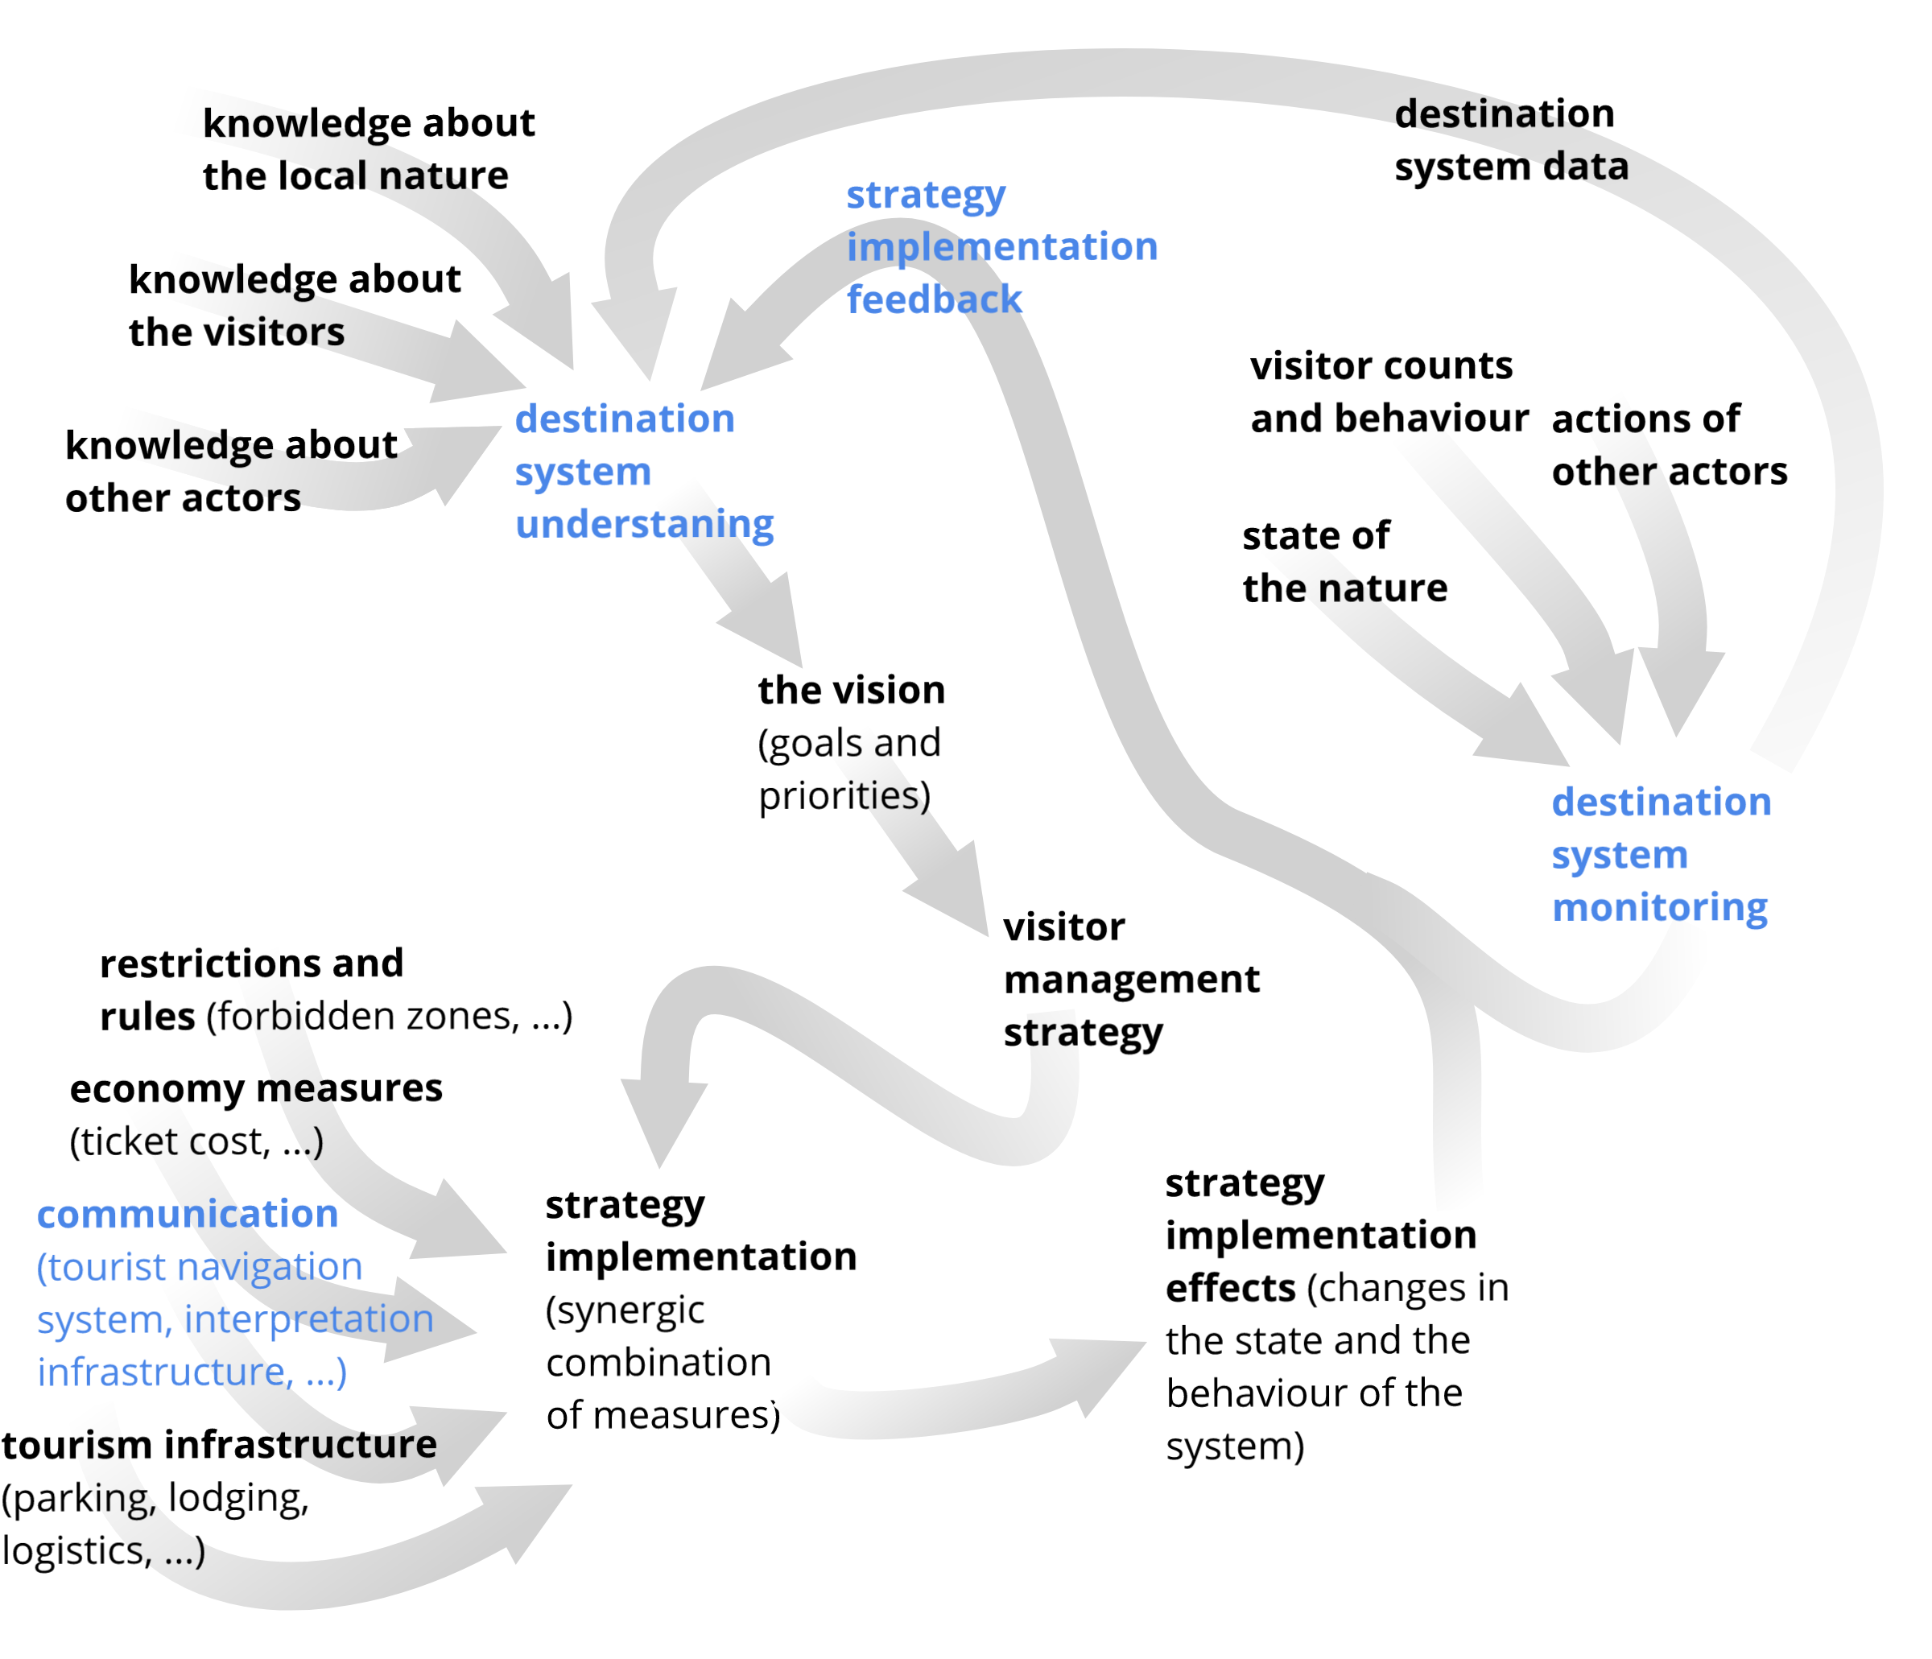
Figure 7 The flow of activity from analyzing the functioning of the destination system, through strategic management, to moving towards visitor optimum.
The extent to which the management of a protected area may benefit from these measures varies; some of them may be fully in within its reach and responsibility, whereas others only to a limited extent or only indirectly, for example through other tourism actors. Should the whole system operate close to the optimum, it is necessary to ensure targeted and consistent application of individual measures. Good coordination with other tourism actors can synergistically enhance the effectiveness of individual measures. Simulation using the destination application which is being implemented will be used to test various combinations of measures. The real impact of the measures on the destination system will then be monitored in a live destination model reflecting the real destination system and further refining the model according to the degree of compliance of the destination model with the destination system. Figure 7 illustrates the proposed systematic approach to visitor management. There are highlighted concepts to which the implementation of the destination application can contribute most. In addition, the destination application itself can also be used as a communication channel between the protected area management and its visitors, thus becoming another tool for the destination system influencing

.

6. Discussion

Vast Complexity of the System
Potential of the mathematical description of the destination system and behavior of its elements is limited mainly by the quantity of the external factors and accumulation effects. Nonlinear behavior of the ecosystem and population dynamics of certain species represent another complication for the destination data predictability, simulation of destination processes and finally for destination model operability. Applying the methodology may be hindered by an excessive complexity of the destination system, which may thwart efforts to create a sufficiently meaningful and acceptably complex destination model. The model have to be based on available current as well as historical data. One of the future research goals is also to help objectivize conditional carrying capacities of the area and its locations (maximum acceptable number of visitors under different external conditions), considering also the non-linear character of the relationship.

Low Quality of Inputs
In practice, an insufficient range and quality of data (e.g., the number of visitor or the current state of monitored natural phenomena) and sometimes the inability of protected area managements to efficiently analyze available data may hinder understanding of DS behavior. Moreover, data may need to be appropriately cleaned, transformed, or otherwise modified prior to their utilization, for which protected area personnel may not have adequate tools or knowledge. For a number of reasons, such a systemic approach is currently applied only rarely. To a greater extent, protected area management staff must rely on intuitive estimates. It is difficult or impossible to assess objectively whether the measures they apply help DS approximate a set objective (e.g., visitor optimum). It is easier for adverse circumstances to occur when either carrying capacity is exceeded or the use of the protected area by tourism is subject to excessive restrictions. Moreover, strategies and measures that are not supported by a credible theoretical basis and systematic monitoring of tourist traffic and its impacts are more difficult to promote with other tourism actors involved in participatory management.

Problems with interpretation
The simplification with which the DeM reflects the DS should be taken into account when working with the model and when interpreting the data that this model helps collect. Effects of some factors may be neglected as well as some synergies and accumulative effects.

7. Conclusions
The visitor management of protected areas faces an increasingly difficult task of reconciling the protective and tourist functions in the area in question. The situation is complicated by the increasing intensity of tourism in the form of higher numbers, growing demands and marked changes in visitor behavior. Sensitive natural elements are also affected by other factors, in particular climate change, industrial pollution, agriculture and invasive species. In particular, the long-term interaction of these influences and gradual accumulation of their impacts may lead to a deep and sometimes irreversible degradation of protected natural resources. The optimum response to these impacts is not merely restrictive measures (severe restrictions on the number of visitors, radical price increases, total bans on entry, etc.) reducing the overall benefits obtained by tourists from using the area in question. Moreover, these measures may adversely affect the local economy and community. It is therefore appropriate to focus further theoretical and applied research on objectification of carrying capacity in relation to visitor optimum and its operationalization. Among suitable approaches belong systemic destination analysis and the creation of a destination model that can be implemented specifically for individual destinations. In protected areas, the existing destination management tools could be made more effective using analytical explanatory and predictive capabilities of the destination model (as shown in the destination life cycle concept, see Butler, 1980; Pásková, 2014) and subsequently supplemented by an active influence on the spatio-temporal curves of visitor behavior (Hägerstrand, 1970) as well as visitor experience, motivation and relation to the territory using the destination application.
Based on the existing experience and knowledge of the authors, literature search, the analysis of typical visitor management approaches and other resources, the theory of carrying capacity has been extended by new concepts and procedures aimed at the operationalization of carrying capacity in the practice of visitor management of protected areas. What was elaborated in more detail was the trajectory, whose influence quantity (e.g. the number of visitors) affects partial influenced variables, where the sum of these impacts can be used to derive individual dimensions of the carrying capacity and thus determine the acceptable intensity of the influence quantity. The concept of visitor optimum was introduced, where the potential of the territory for tourism is maximized, without exceeding the carrying capacity of the territory as a whole as well as its individual dimensions, together with the concepts of parameterized, conditional, potential and effective carrying capacity. Attention was also paid to the territorial structure of the carrying capacity. The methodology for systematic analysis of the impact of tourism in ecologically sensitive and frequently visited destinations, to which protected areas belong, was briefly presented. The methodology aims to construct a destination model, whose purpose is to reflect the structure, character and functioning of the system under various external conditions (e.g. weather, calendar). A destination model can be implemented as part of a destination application that provides the protected area authority with a better understanding of processes within the area, including real-time reflection of the state of the system in relation to the carrying capacity of each site and visitor optimum, and the possibility of short-term predictions or simulations of different scenarios. Last but not least, the construction of such a destination model will enable to formulate strategic management of attendance (as a part of visitor management), based on an objective basis. Subsequently, it will enable to select a combination of measures that will be directed towards the fulfilment of the strategy. Experimental verification of the methodology and the concepts derived from it is a subject of applied research that is currently taking place in several protected areas in the Czech Republic České Švýcarsko (Bohemian Switzerland) National Park, Železné hory (Iron Mountains) Protected Landscape Area, Broumovsko Protected Landscape Area, Český ráj (Bohemian Paradise) Protected Landscape Area. The validation of the methodology in several specially protected areas will make it possible to find both common features and differences of the respective destination systems, which should also be reflected in the respective destination models. It can be assumed that the experience gained from the application of the methodology, the created models and the software source codes compiled according to the proposed principles will facilitate possible future deployment of the solution for other specially protected areas.
The model developed in this way may sufficiently reflect the functional dependencies that apply to these data. On the other hand, the established functional relationship may no longer adequately match future data. The results of applied research may also lead to questioning some of the key theoretical parts of the methodology - for example the concept of visitor optimum. If that is the case, the methodology will be adjusted accordingly.

Author Contributions: For research articles with several authors, a short paragraph specifying their individual contributions must be provided. The following statements should be used “All authors have read and agree to the published version of the manuscript. Conceptualization, X.X. and Y.Y.; methodology, X.X.; software, X.X.; validation, X.X., Y.Y. and Z.Z.; formal analysis, X.X.; investigation, X.X.; resources, X.X.; data curation, X.X.; writing—original draft preparation, X.X.; writing—review and editing, X.X.; visualization, X.X.; supervision, X.X.; project administration, X.X.; funding acquisition, Y.Y.”, please turn to the CRediT taxonomy for the term explanation. Authorship must be limited to those who have contributed substantially to the work reported.
Author Contributions: All authors have read and agree to the published version of the manuscript. Conceptualization, M.P., D.Z. and J.Z.; methodology M.P. and D.Z.; software D.Z; validation, J.Z; formal analysis, M.P., J.Z. and D.Z.; investigation, D.Z.; writing, D.Z, M.P. and J.Z.; supervision, M.P.; project administration, J.Z; funding acquisition, J.Z.
Funding: This work was supported by the FIM UHK under the Grant of the Specific Research Project “Information and knowledge management and cognitive science in tourism”.
Conflicts of Interest: The authors declare no conflict of interest. The funders had no role in the design of the study; in the collection, analyses, or interpretation of data; in the writing of the manuscript, or in the decision to publish the results.

References
- Ahn, B., Lee, B., & Shafer, C. S. (2002). Operationalizing sustainability in regional tourism planning: an application of the limits of acceptable change framework. Tourism Management, 23(1), 1–15, doi: 10.1016/S0261-5177(01)00059-0
- Albrecht, J. N. (ed.; 2016). Visitor Management in Tourism Destinations. CABI Series in Tourism Management Research, 208 p., ISBN 9781780647357.
- Amir, S. et al. (2015). Sustaining Local Community Economy through Tourism: Melaka UNESCO World Heritage City, Procedia Environmental Sciences, Vol. 28, pp. 443-452, doi: 10.1016/j.proenv.2015.07.054.
- Bednar-Friedl, B., Behrens, D. A., & Getzner, M. (2012). Optimal Dynamic Control of Visitors and Endangered Species in a National Park. Environmental and Resource Economics, 52(1), 1–22, doi: 10.1007/s10640-011-9515-5
- Bella, L. (1987). Parks for profit. Montreal: Harvest House.
- Bušek, M., Pásková, M., & Zelenka, J. (2016). Landscape Perception of the Bohemian Paradise. Czech Journal of Tourism, 5(2), 111–133, doi: 10.1515/cjot-2016-0007
- Butler, R. W. (1980): The Concept of a Tourism Area Cycle of Evolution: Implication for Management of Resources. Canadian Geographer, Vol. 24, No. 1, pp. 5–12.
- Canestrelli, E., & Costa, P. (1991). Tourist carrying capacity: A fuzzy approach. Annals of Tourism Research, 18(2), 295–311, doi: 10.1016/0160-7383(91)90010-9
- Clarke, J. (1997). A Framework of Approaches to Sustainable Tourism. Journal of Sustainable Tourism, 5(3), 224–233, doi: 10.1080/09669589708667287
- Cole, D. N. (2005). Computer simulation modeling of recreation use: Current status, case studies, and future directions. Gen. Tech. Rep. RMRS-GTR-143. Fort Collins, CO: U.S. Department of Agriculture, Forest Service, Rocky Mountain Research Station. 75 P., 143, doi: 10.2737/RMRS-GTR-143
- Dearden, P., & Berg, L. (1993). Canada's national parks: A model of administrative penetration. Canadian Geographer, 37, 194-211.
- Dowling, R. K., & Newsome, D. (Eds.). (2006). Geotourism. Routledge.
- Doxey, G. V. A. (1975): Causation Theory of Visitor-Resident Irritants; Methodology and Research Inference. In: The Travel Research Association Conference No. 6. San Diego: TTRA, pp. 195-198.
- Eagles, P. (1993). Parks legislation in Canada. In P. Dearden, & R. Rollins (Eds.), Parks and protected areas in Canada: Planning and management. Toronto: Oxford University Press.
- Firsov A.N. (2016). Mathematical Modeling as a Key to System Analysis Methodology. Industry 4.0, 1 (1), 25-27.
- Frauman, E., & Banks, S. (2011). Gateway community resident perceptions of tourism development: Incorporating Importance-Performance Analysis into a Limits of Acceptable Change framework. Tourism Management, 32(1), 128–140, doi: 10.1016/j.tourman.2010.01.013
- Gimblett, R., & Skov-Peterson, H. (2008). Monitoring, Simulation, and Management of Visitor Landscapes. University of Arizona Press.
- Gimblett, R., Daniel, T., Cherry, S., & Meitner, M. J. (2001). The simulation and visualization of complex human-environment interactions. Landscape and Urban Planning, 54(1/4), 63–78.
- Goodwin, H. (2002). Cape Town Declaration on Responsible Tourism – Responsible Tourism Partnership. Retrieved December 19, 2018, from http://responsibletourismpartnership.org/cape-town-declaration-on-responsible-tourism/
- Goossen, M. (2014). New ideas for monitoring visitors. The 7th International Conference on Monitoring and Management of Visitors in Recreational and Protected Areas (MMV)–Local Community and Outdoor Recreation, 121–122. Retrieved from http://www.tlu.ee/UserFiles/Konverentsikeskus/MMV7/MMV%20PROCEEDING.pdf
- Gundersen, V. et al. (2019). Large-scale segregation of tourists and wild reindeer in three Norwegian national parks: Management implications, Tourism Management, Vol. 75, pp. 22-33, doi: 10.1016/j.tourman.2019.04.017.
- Hägerstrand, T. (1970). What about people in regional science? Papers of the Regional Science Association 24, 7-21.
- Hammitt, W., & Cole, D. (1998). Wildland recreation: Ecology and management (2nd ed.). New York: Wiley.
- Hose, T. A. (2000). European geotourism–geological interpretation and geoconservation promotion for tourists. Geological heritage: its conservation and management. Instituto Tecnologico Geominero de Espana, Madrid, 127-146.
- Inskeep, E., & World Tourism Organization. (1998). Guide for local authorities on developing sustainable tourism. Madrid, Spain: World Tourism Organization.
- Iranah, P. et al. (2018). Valuing visitor access to forested areas and exploring willingness to pay for forest conservation and restoration finance: The case of small island developing state of Mauritius, Journal of Environmental Management, Vol. 223, pp. 868-877, doi: 10.1016/j.jenvman.2018.07.008.
- Jochem, R., Pouwels, R., & Visschedijk, P. A. (2006). MASOOR: the power to know-a story about the development of an intelligent and flexible monitoring instrument. Exploring the Nature of Management; Proceedings of the Third International Conference on Monitoring and Management of Visitor Flows in Recreational and Protected Areas, Rapperswil, Switzerland, 13-17-09-2006, 338–341.
- Johnston, R. J., & Tyrrell, T. J. (2005). A Dynamic Model of Sustainable Tourism. Journal of Travel Research, 44(2), 124–134, doi: 10.1177/0047287505278987
- Kuba, K., Monz, C., Bårdsen, B.-J., & Hausner, V. H. (2018). Role of site management in influencing visitor use along trails in multiple alpine protected areas in Norway. Journal of Outdoor Recreation and Tourism, 22, 1–8, doi: 10.1016/j.jort.2018.02.002
- Lanchava, O., Bolashvili, N., Naskhidashvili, A., Tsikarishvili, K., Lezhava, Z., Tsagareishvili, S., & Chartolani, G. (2018). Determination of the Simultaneously Allowed Optimal Number of Tourists for the Tskaltubo (Prometheus) Cave. Open Journal of Geology, 08, 437, doi: 10.4236/ojg.2018.84025
- Lawton, L. (2001). Ecotourism in public protected areas. In D. Weaver (Ed.), The Encyclopedia of Ecotourism (pp. 287–302). Wallingford, UK: CAB International.
- Leung, Y.-F., Spenceley, A., Hvenegaard, G., Buckley, R., & Groves, C. (2018). Tourism and visitor management in protected areas. Retrieved from https://portals.iucn.org/library/node/47918
- Liu, Z. (2003). Sustainable Tourism Development: A Critique. Journal of Sustainable Tourism, 11(6), 459–475. doi: 10.1080/09669580308667216
- Marsiglio, S. (2017). On the carrying capacity and the optimal number of visitors in tourism destinations. Tourism Economics, 23(3), 632–646, doi: 10.5367/te.2015.0535.
- Mason, P. (2015). Tourism Impacts, Planning and Management, Routledge, London, 3rd Edition, 272 pages, DOI: 10.4324/9781315781068.
- McNamee, K. (1993). From wild places to endangered spaces: A history of Canada's National Parks. In P. Dearden, & R. Rollins (Eds.), Parks and protected areas in Canada: Planning and management. Toronto: Oxford University Press.
- Papageorgiou, K., & Brotherton, I. (1999). A management planning framework based on ecological, perceptual and economic carrying capacity: The case study of Vikos-Aoos National Park, Greece. Journal of Environmental Management, 56(4), 271–284, doi: 10.1006/jema.1999.0285.
- Parsons, D., Graber, D., Agee, J., & Van Wagtendonk, J. (1986). Natural fire management in national parks. Environmental Management, 10, 21-24.
- Pásková, M. (1999). Negative Impacts of Tourism and Sustainable Tourism as an Alternative for Regional Development. In: Regional Prosperity and Sustainability. Proceedings of the 3rd Moravian Geographical Conference CONGEO ´99, Slavkov u Brna, pp. 155 – 167.
- Pásková, M. (2002): Destination life cycle of the historic town Český Krumlov. Tourism, 50 (3), pp. 249-26, eid=2-s2.0-0036988372.
- Pásková, M. (2012). Environmentalistika cestovního ruchu (Tourism Environmentalism). Czech Journal of Tourism, 1(2), 77–113.
- Pásková, M. (2014). Udržitelnost cestovního ruchu (Tourism Sustainability), Gaudeamus Hradec Králové, 3rd ed, 335 p.
- Pásková, M. (2018). Can Indigenous Knowledge Contribute to the Sustainability Management of the Aspiring Rio Coco Geopark, Nicaragua? Geosciences, 8(8), p. 277, doi: 10.3390/geosciences8080277.
- Pásková, M., & Zelenka, J. (2016). Social Responsibility Role in Tourism Sustainability. Proceedings of Hradec Economic Days, February 2nd and 3rd, 2016, 2016, 777–785.
- Pásková, M., & Zelenka, J. (2018). Společensky odpovědný cestovní ruch (Socially responsible tourism). IDEA Servis Prague.
- Prokopis A. Ch., Farmaki, A., Saveriades, A., Spano, E. (2019). The “genius loci” of places that experience intense tourism development, Tourism Management Perspectives, Vol. 30, pp. 19-32, DOI: 10.1016/j.tmp.2019.01.002.
- Ripple, W., & Larsen, E. (2000). Historic aspen recruitment, elk, and wolves in northern Yellowstone National Park, USA. Biological Conservation, 95, 361e370.
- Ryan, R. M., Weinstein, N., Bernstein, J., Brown, K. W., Mistretta, L., & Gagne, M. (2010). Vitalizing effects of being outdoors and in nature. Journal of environmental psychology, 30(2), 159-168.
- Salerno, F., Viviano, G., Manfredi, E. C., Caroli, P., Thakuri, S., & Tartari, G. (2013). Multiple Carrying Capacities from a management-oriented perspective to operationalize sustainable tourism in protected areas. Journal of Environmental Management, 128, 116–125, doi: 10.1016/j.jenvman.2013.04.043
- Schuhmann, P. W. et al. (2019). Visitors’ willingness to pay marine conservation fees in Barbados, Tourism Management, Vol. 71, pp. 315-326, doi: 10.1016/j.tourman.2018.10.011.
- Skov-Petersen, H. (2005). Feeding the agents-collecting parameters for agent-based models. Batty, SE Computers in Urban Planning and Urban Management (60). Retrieved from http://128.40.111.250/cupum/searchpapers/papers/paper60.pdf
- Steiner, F. (1997). Optimal Pricing of Museum Admission. Journal of Cultural Economics, 21(4), 307–333, doi: 10.1023/A:1007432901540
- Taylor, P. W. (1981). The ethics of respect for nature. Environmental ethics, 3(3), 197-218.
- Wall, G. (1982): Cycles and Capacity: Incipient Theory or Conceptual Contradiction? Tourism Management, 3(3), 188–192.
- Wearing, S. (2001). Volunteer Tourism: Experiences That Make a Difference. CABI.
- Weaver, D. B. (1990). Grand Caymann Island and the Resort Cycle Concept. Journal of Travel Research, 29(2), SAGE Publications, London, 9-15.
- Weaver, D. B. (2000). A Broad Context Model of Destination Development Scenarios. Tourism Management, 21(3), 217-224.
- Weaver, D. B., Lawton, L. J. (2007). Twenty years on: The state of contemporary ecotourism research, Tourism Management, Vol. 28, No. 5, pp. 1168-1179, doi: 10.1016/j.tourman.2007.03.004.
- Weaver, D., & Lawton, L. (2017). A new visitation paradigm for protected areas. Tourism Management, 60, 140–146.
- Zelenka, J., & Kacetl, J. (2013). Visitor management in protected areas. Czech Journal of Tourism, 2(1), 5–18, doi: 10.2478/cjot-2013-0001
- Zelenka, J., & Kacetl, J. (2014). The Concept of Carrying Capacity in Tourism. Amfiteatru Economic, 16(36), 641–654.
© 2020 by the authors. Submitted for possible open access publication under the terms and conditions of the Creative Commons Attribution (CC BY) license (http://creativecommons.org/licenses/by/4.0/).

